

Public Sector Principles
Conversation Guide

Purpose
The purpose of this guide is to support a conversation about Ngā pou | principles, and how they apply to us as public servants.
We encourage people leaders to facilitate an informal conversation in small groups or teams using the discussion questions and prompts provided in this guide. While we recommend a people leader facilitates the conversation, you may also wish to have someone who knows about internal integrity policies present to direct participants.
This guide isn’t exhaustive – it’s simply a resource to get you started. You are best placed to know your agency’s context and how to make sure these key messages land for your people.

Delivery
It’s recommended that you allow at least 30 minutes for the conversation. This learning could be included as a part of a regular team meeting, or as a one-off session to learn more about Ngā pou | principles.
We recommend you have a safe and quiet space to support open discussion within the group.​
What you need:
- Use the powerpoint guide to support the conversation. This is particularly useful if delivering the conversation online.
- Familiarise yourself with the questions and prompts on pages 2, 3 and 4 of this guide.
- It is a good idea to have the Ngā Pou | Principles Guidance handy, as well your own agency information about internal processes and practices.
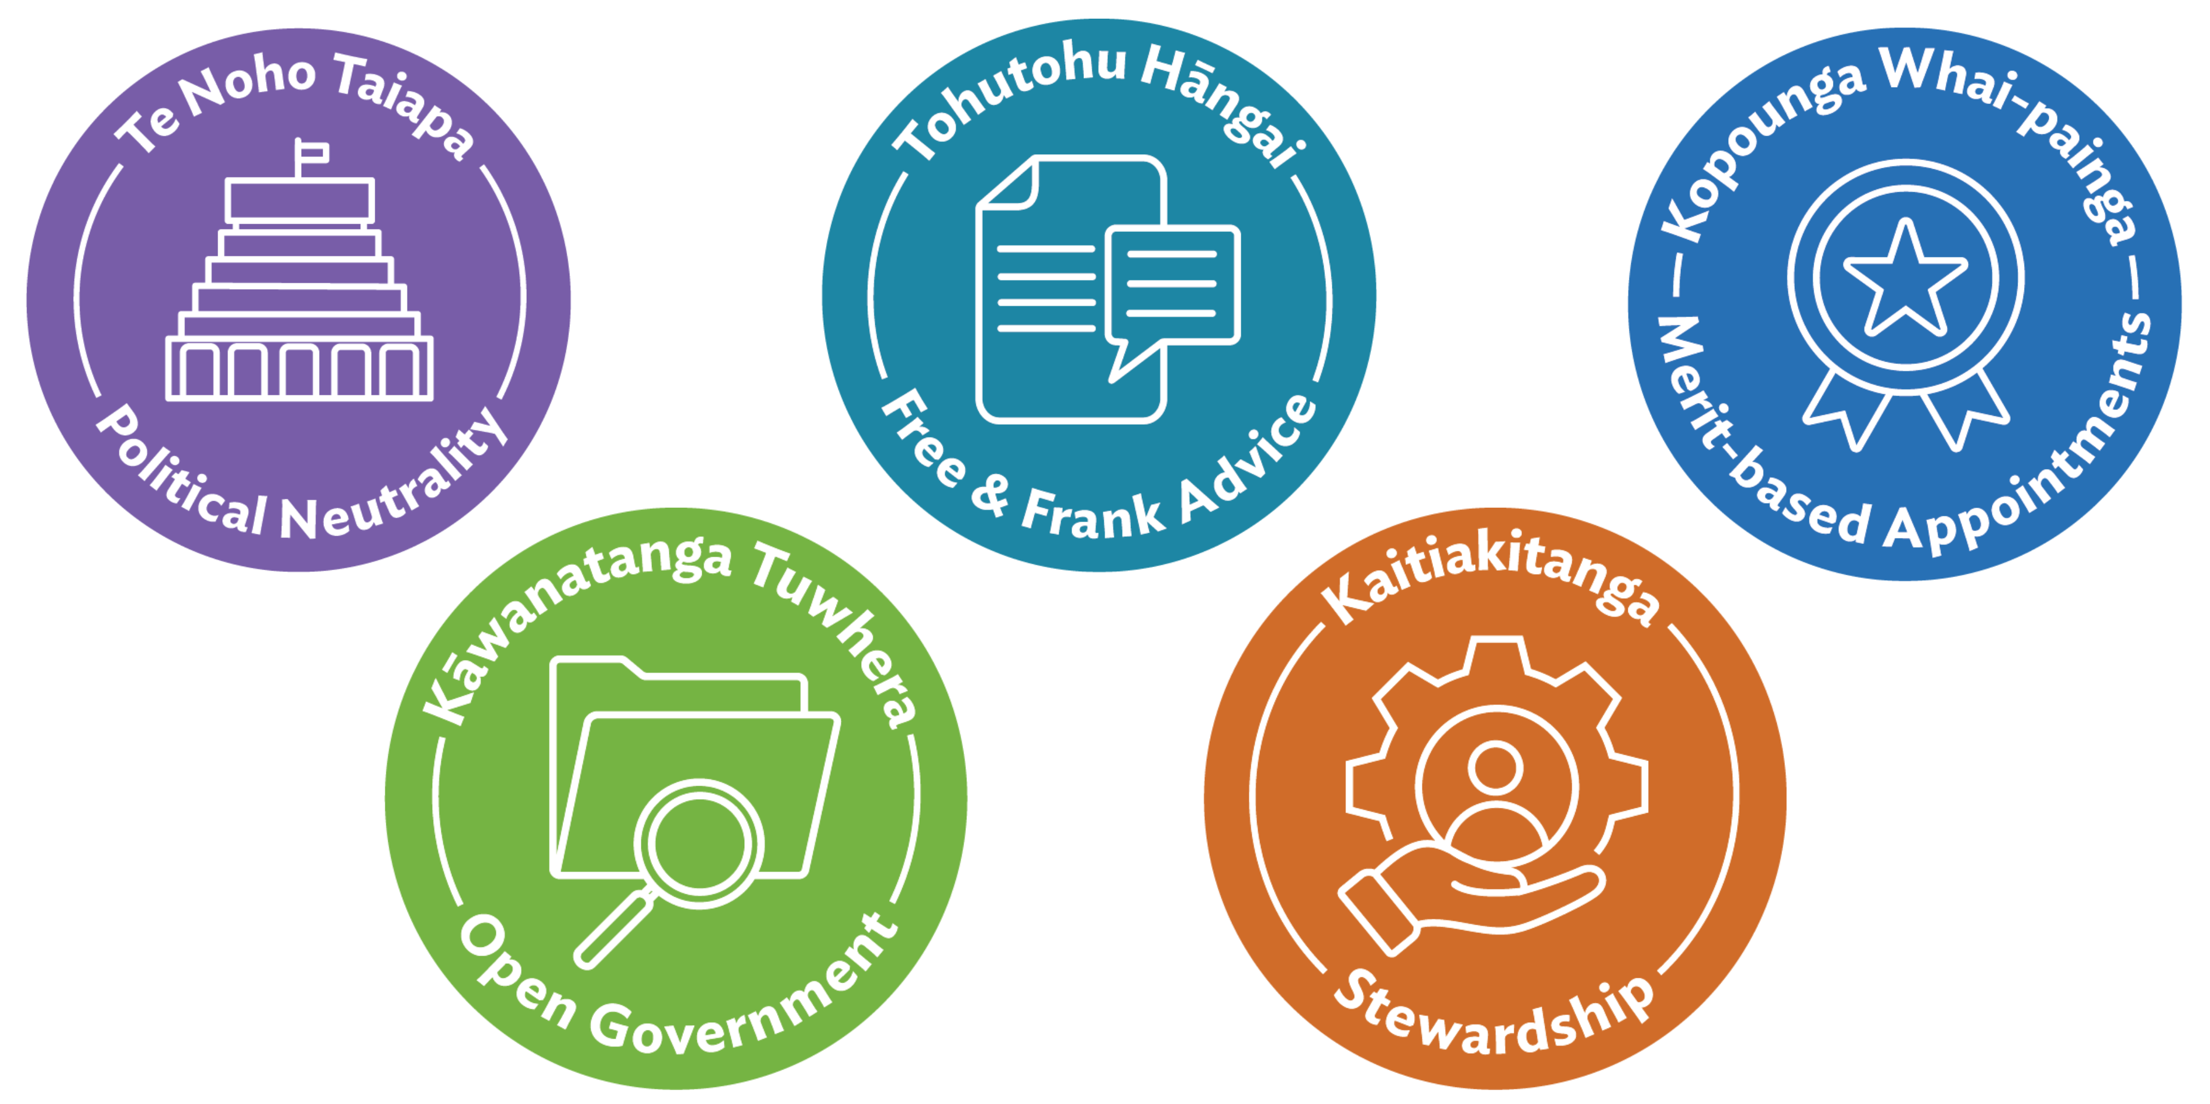

Context and scene setting
As public servants, we are all connected by a similar goal, to serve the people of Aotearoa New Zealand.
Ngā pou | principles are outlined in the Public Service Act 2020. No matter what role, agency or where you are on your journey, these principles guide how we work.
Ngā pou | principles
These are the fundamental principles that guide our actions and how we work.
- Te noho taiapa | Political neutrality
- Tohutohu hāngai | Free and frank advice
- Kopounga whai-painga | Merit-based appointments
- Kāwanatanga tuwhera | Open government
- Kaitiakitanga | Stewardship

Warm-Up Prompt: (whiteboard, brainstorm or general conversation)
Ask participants about their initial thoughts regarding the five principles.
- In plain terms what do these principles mean to you?
- What is the importance of upholding the principles?
- What are the consequences if we don’t?

Discussion Questions by Principle

Te noho taiapa - Political Neutrality
Question: What does it mean to be politically neutral, and why is it so important in the Public Sector?
Prompt: Political neutrality is a fundamental principle within our Public Sector. It is about the way we act as public servants to support the government of the day to develop and implement their policies.
It is important because:
- We serve current and future governments.
- We maintain the trust and confidence of ministers and the government.
- We build and maintain the trust and confidence of the public.

Tohutohu hāngai - Free and Frank Advice
Question: What does “free and frank advice” look like in your role?
Prompt: It’s about being honest and courageous in our advice -even when it’s challenging. How do we create space for that in our teams?
It is important because:
- We provide ministers with the best possible information to make decisions.
- We foster a culture of openness and trust within our teams.
- We uphold our responsibility to act in the public interest.

Kopounga whai-painga - Merit-based Appointments
Question: Why is it important that appointments are based on merit?
Prompt: Merit ensures fairness, capability, and diversity. How do we see this principle in action in recruitment or development opportunities?
It is important because:
- We promote fairness and transparency in recruitment.
- We build a capable and diverse workforce.
- We strengthen public confidence in the Public Sector.

Kāwanatanga tuwhera - Open Government

Question: What impact do you think open government has on New Zealanders?

Prompt: Open government strengthens our democracy by ensuring citizens can contribute and influence what the government does and how it does it. The impact of open government is a public sector that is transparent, so people can understand the actions of government, and where decisions can be held to account. It also increases the ability for anybody to participate and influence what the government does or how it does it.

It is important because:
- We raise public understanding of how government works.
- We promote participation.
- We demonstrate our accountability to the public.

Kaitiakitanga - Stewardship
Question: What does stewardship mean to you in your day-to-day work?
Prompt: Stewardship is about looking after people, knowledge, and resources for the long term. How do we pass on what we know and care for what we have?
It is important because:
- We ensure continuity and resilience in public services.
- We support future generations of public servants and communities.
- We protect the integrity and sustainability of our work.

Wrap-up and Next Steps
Encourage people to share real examples, big or small, from their work.
Check out He Aratohu | A Guide on Integrity and Conduct. He Aratohu | A Guide on Integrity and Conduct.

