Getting Election Ready

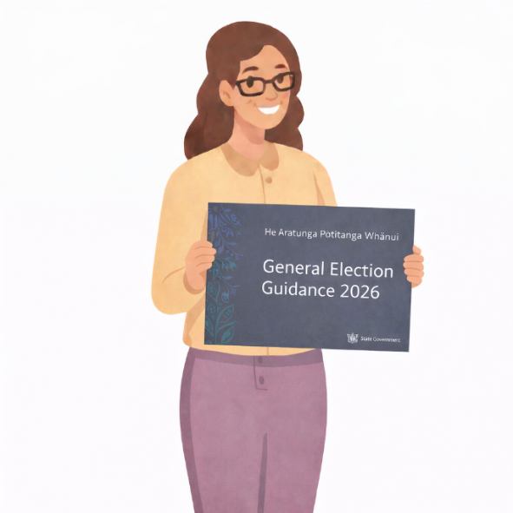

Every 3 years, New Zealand has a general election. For us as public servants, that means increased scrutiny around how we conduct ourselves and that we need to continue to uphold political neutrality. To that effect, Te Kawa Mataaho Public Service Commission has developed the He Ārahitanga Pōtitanga Whānui | General Election Guidance (Election Guidance), which covers what it means to work in the public sector in the lead up to, during, and after an election.

Getting Started

Kia ora, I’m Miriam.
I’ve been in the Public Service for a while now. I always find things a bit confusing around an election. Since elections only tend to happen every 3 years, they aren't something I think about often.
Let's look at some interesting facts about the election period.

- Depending on your role in the public service, you can actively participate in politics outside work - including attending meetings, delivering pamphlets, and even standing for Parliament.
- On election day, there is a complete ban on all political advertising, campaigning or posting on social media. This is to make sure no one is doing anything that may influence voters.
- Agencies must support government information requests even during coalition negotiations - but only through a tightly controlled process coordinated by the Public Service Commissioner.

Surprising right?! This module will cover how to protect the political neutrality we’re trusted to uphold as public servants. We’ll also learn how we can take part in democracy outside of work

Reflection
Before we get started, take a moment to reflect on your current understanding of the role of public servants and agencies during an election.

On a scale of 1–10, how confident do you feel in your knowledge of what the Code expects of you in your role? (1 = not confident at all, 10 = very confident).

Remember your score, I will ask you again later in the module.

Quote from Sir Brian Roche, Public Service Commissioner
"By following the principles set out in the General Election Guidance, we can make sure that together we protect the integrity of the public sector and strengthen confidence in our democratic system."

Before, During, and After an Election
A general election is held every 3 years, although snap elections can be called at any time by the Prime Minister.

There are 3 parts to the election cycle:
- the pre-election period
- election day
- the post-election period.

There are some key things that public servants need to know about the three different parts of the election period. Here is a summary of these three parts:
- Pre-Election period: The pre-election period is generally the 3 months immediately before election day.
- Election Day: Election Day is where all eligible voters have the opportunity to cast their votes and elect the next government.
- Post-Election Period: The post-election period runs from the day after election day until the new government is sworn in.

The Pre-Election Period
This is generally the 3 months prior to Election Day.

During the pre-election period, things are largely business-as-usual. But governments have chosen to exercise restraint in some areas to recognise the upcoming election.

Exercise of Voluntary Restraint
In the pre-election period, the Government continues to have full power to make decisions.

However, successive governments have usually chosen to exercise restraint in this period, particularly in relation to:

- making significant appointments
- some government advertising

Working on Government Policy
In the pre-election period, Ministers continue to commission policy work that goes through the Cabinet and Cabinet Committee decision-making process.
However, Ministers should not request policy work to support their party-political work, for example, to use in party manifestos.

Election Day
On election day, everyone goes to the polls and everything political goes quiet. All political advertising is banned (including on social media).
Once voting closes, the Electoral Commission releases the preliminary results that evening, and the official results land within about 3 weeks.
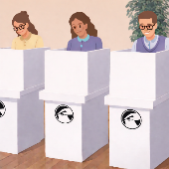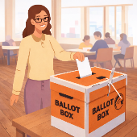

The Post-Election Period
There are a few things that happen after election day and before a new government is sworn in.

The Caretaker Convention
The caretaker convention kicks in after an election.
During this time, the incumbent government still has all its usual legal powers and day-to-day administration can continue, but some decision-making is constrained and public servants should plan accordingly.
If we don’t yet know (exactly) who the new government will be, day-to-day administration carries on but anything significant or new should be pushed out. If that isn’t possible, temporary arrangements can be put in place. And if that isn’t possible, decisions are made after talking with other political parties (this is done via agencies’ senior managers and the Prime Minister’s Office).
Once it’s clear who’s forming the next government, the outgoing government should avoid doing anything significant and act on the advice of the incoming government before making any big decisions - even if they don’t agree with them.



Forming a government
During negotiations to form a government, political parties might ask for information from the public sector. The Public Service Commissioner runs the process and acts as the go-between for political parties and agencies.

Once a government has been formed
Once Ministers are officially appointed, chief executives make sure their agency provides a Briefing for the Incoming Minister (BIM) for each of their portfolios. A BIM gives a new Minister the essentials, like:
- what the agency or entity does
- any major policy issues that are still unresolved
- current programmes on the go
- recommendations for draft legislation
- any big appointments or decisions likely to pop up in the first 6 months.
It’s really a starter pack - enough to get a new Minister up to speed, without going super deep into every policy detail.
BIMs are confidential to the Minister, and it’s their call if (and when) they decide to release them under the Official Information Act (OIA).
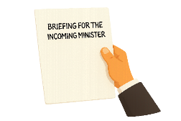

Expectations of the Public Service during the Election Period
Serving the Government means doing our jobs fairly, professionally, and without favour. That doesn't change come election time, but ther e can be some added challenges.
Let’s take a look at some of the trickier bits around staying politically neutral during an election period.

Expectations in the workplace
There are some expectations at work that public servants need to be extra mindful of during an election year.

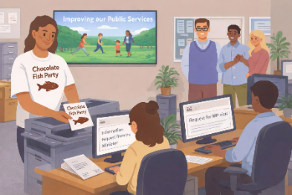

Political Neutrality
As public servants, we have the same rights to freedom of speech and political activity in our private lives as other New Zealanders.
But in the workplace, we also need to respect the rights and interests of others and make sure we’re not doing anything that could undermine the political neutrality of the public sector.
For example, at work it’s not appropriate to:
- wear a t-shirt with political party advertising
- campaign for a political party or candidate
- give your work contact details to political parties for personal reasons
- interact with political parties in a personal capacity.

Advertising and Publicity Campaigns
Government advertising is any use of public money to promote a government policy, service, product, or activity. It is important public money is never used for, or perceived to be used for, party political purposes.
Government advertising must only deal with matters the Government is responsible for and must only take place when there is a public information need. Agencies need to think carefully about the purpose, timing, and audience of any government advertising, and sometimes it may be better to delay it, depending on the proximity to the election.
In the past governments have usually chosen to exercise voluntary restraint in relation to some advertising campaigns in the 3 months leading up to an election (the pre-election period).
At the same time, normal business still needs to continue in the pre-election period. Examples of business-as-usual advertising that should continue include:
- road safety campaigns
- public health information
- telling people about services, entitlements, or obligations
- promoting NZ export goods and services overseas.

Programme launches and events
Agencies have to be careful about when and how they run programme launches or events to protect political neutrality, especially high-profile ones or those involving Ministers or Members of Parliament.
This can mean being selective about who’s speaking, the topics, the audience, and the venue.
If managed carefully, the following would be okay (depending on the situation):
- an agency releasing a technical report, with the Minister issuing a press release
- a media event marking the completion of a major project
- a chief executive attending an international meeting of Ministers on behalf of their agency (not as the Minister's representative).

Using public funds and resources appropriately
It’s never okay to use an agency’s public funds or resources for political purposes.
For example, using a work printer to copy political party material is not allowed, you can’t use an agency vehicle to take Ministers to a political event, or use agency money to cater an event the Minister is hosting for party colleagues. Agency premises also shouldn’t be used for political activity.

Information requests
During the election period, agencies and Ministers still need to release government information as they normally would - whether proactively or in response to Official Information Act (OIA) requests.
When Ministers ask for information, agencies need to keep political neutrality in mind. Your Minister must make sure any requests for advice or information relate to their portfolio, not party-political purposes. If it is the latter, it should go to the agency as an OIA request instead.

Managing political visits
During the pre-election period, MPs might ask to visit agency premises - whether as a Minister, local MP, party leader, or candidate.
The agency’s chief executive needs to think about any risks to political neutrality and can decline a visit if it looks like it could compromise that, or if the request just isn’t appropriate for the agency.
Things the chief executive may consider include:
- the role the MP is acting in
- the nature and purpose of the visit
- whether government or party representatives will be there
- the timing of the visit.

Read more about the requirements at work during the election period on the Public Service Commission’s website.

Public servants at work (Public Service Commission)

Expectations outside the workplace
Public servants have the same rights to freedom of speech and political activity as other New Zealanders. However, at work we are required to be politically neutral. This means there must be a clear separation between the work role of public servants and their personal political interests.

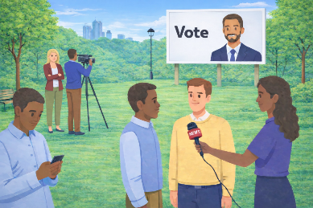

Appearing in publicity material
Public servants need to be politically neutral in our official roles. If we do not tie our roles as public servants with our political interests, it may be okay for us to appear in political party publicity material.

For example, it may be okay to appear in a campaign and say:

"As a proud New Zealander, this party's policies really resonate with me."

However, we can't appear in party political material in our official capacity. That could imply that we are endorsing the party on behalf of our agency or the Public Service and compromise political neutrality. It would therefore not be okay to say:

"As a Senior Advisor at the Ministry for Sausage Sizzles, this party's policies really resonate with me."

In some roles, it can be harder to balance personal political interests with the job. Extra care is needed if you:

- are very senior
- work closely with Ministers
- work in a Minister’s office or advise on politically sensitive issues.

Standing for Parliament
Public servants have the same right to stand for election to Parliament as other New Zealanders.
Most public servants running for parliament will be required to take a leave of absence from Nomination Day (which is usually about one month before the election) if not earlier. During the period of leave, they should not carry out any official duties. They are also not entitled to any salary or other remuneration except paid annual leave.
If standing for election, public servants must separate their political candidacy from their work role and their agency. They should also take care not to appear to use their employment for political advantage or act in a way that is inconsistent with the Code of Conduct for the Public Sector.
It is important the public servant standing for election notifies their agency as soon as possible and together they agree on a management plan.
Board members who are thinking of standing for election are advised to discuss it with their Chair and monitoring department.
After the election, if the public servant has been elected they will be required to stand down effective immediately from their public service role. Unelected candidates are able to return to work the day after the election.

Using social media
Public servants can use social media in their private lives just like anyone else.
The key is keeping your work role separate from your personal views and making sure your posts or comments don’t impact public sector political neutrality.
Remember that private comments can easily become public online, so think before you post and use good judgement. If you’re not sure what’s okay, talk to your manager or HR team.

Managing political interests
We all have our own personal political views, and being neutral at work doesn’t usually stop you from being politically active in your own time.
When someone has significant political interests, the agency and the employee can agree on ways to manage any political neutrality risks while still supporting their right to be politically active outside work.
In some roles, it can be harder to balance personal political interests with the job. Extra care is needed if you:
- are very senior
- work closely with Ministers
- represent your agency
- work in a Minister’s office or advise on politically sensitive issues.

Interacting with the media
Public servants can talk to the media and use social media in their private lives just like anyone else.
What matters is keeping a clear line between your work role and your personal views. For example, you can appear in a TV interview as a private citizen, as long as it’s clear you’re not speaking for your agency.
Staying politically neutral means keeping any personal political comments separate from your job.

Read more about the requirements outside of work during the election period on the Public Service Commission’s website.
Public servants outside of work (Public Service Commission)

An information request from the Minister
Last election, we had a tricky situation in my agency, the Ministry for Sausage Sizzles.
Our Minister asked for some information after a news story broke. Check out how we dealt with it below.

Breaking News
2 months out from the last General Election, the local news channel ran this story.


“Good evening, and welcome to XYZ News.
We begin tonight with a breaking story: a new political poll has just been released, and it’s causing quite a stir in the capital with less than 2 months until the General Election. The poll shows significant shifts in voter sentiment across the country, with some surprising results in key electorates.
One of the most notable findings is in the electorate of Harbour City, where Minister Shelley Turnwell, the Minister for Sausage Sizzles, is facing a sharp decline in support. According to the data, Minister Turnwell is polling at just 15% - down nearly 20% from last quarter.
In a statement made to XYZ news, Minister Turnwell has remained adamant that her government’s policies on unattended barbeques have shown demonstrable success in minimising barbecue-related harm across the country. She also said she was looking forward to discussing the strides her government has made during our live election debate next week.
We’ll have full analysis of what these numbers mean for the upcoming election later in the program. But first, we’re crossing live to our reporter Tomas Hernandez for the full story.”

A request from our Minister
We then received the following request for information from our Minister's Office.
Dear Ministry team,
The Minister for Sausage Sizzles is requesting information on the following:
- The most recent national statistics on sausage-sizzle related burns from public BBQs over the past year.
- The number of barbecue-related complaints that have been received in the Harbour City electorate this year.
- The decrease in barbecue-related injuries across New Zealand since she became Minister. This will be used for the upcoming political debate next week so please put a rush on this.

Kind regards,
Office of The Hon. Shelley Turnwell
Minister for Sausage Sizzles

How we handled the request
This request needed to be handled with particular care.
We had to determine if the information request was for the purposes of the Minister’s portfolio responsibilities and could be provided directly to the Minister’s office or if it should be processed under the Official Information Act.

- The most recent national statistics on sausage-sizzle related burns from public BBQs over the past year - This request was within the scope of the Minister's portfolio and is information the Ministry holds. So, it was appropriate to provide this information to the Minister.
- The number of barbecue-related complaints that have been received in the Harbour City electorate this year - This was a tricky one. The mention of a specific electorate felt party political. After seeking clarification with the Minister’s office, we dealt with this as an Official Information Act request from an MP. We refused on the basis that we did not hold the information requested, as our data is broken down by region not electorate.
- The decrease in barbecue-related injuries across New Zealand since she became Minister - The reference to a political debate alerted us to this being an Official Information Act request from an MP. We held the information across a range of teams and undertook work to collate a response. We treated this like any other OIA request – the reference to party politics and the sender did not change the urgency or the process we undertook.

Read more about releasing information during the election period on the Public Service Commission’s website.
Government processes before, during and after an election (Public Service Commission)

Expressing your own democratic rights
Being politically neutral at work doesn’t usually stop you from being involved in politics in your own time. But sometimes your personal views and your public sector role can bump into each other.
To keep things clean and simple, just make sure you keep your job out of your politics, and your politics out of your job!
This looks like:
- Not tying your personal opinions back to your agency.
- Not giving the impression you’re speaking on behalf of your agency when sharing personal opinions.
- Never using confidential government information for any non-work purpose, including anything political.

Keeping It Neutral
Ray is wanting to campaign for the Chocolate Fish Party in the upcoming election.
She is a Senior Advisor in the IT team at the Ministry for Sausage Sizzles. In her day-to-day role, she has no engagement with either her Minister or community members. She has declared her political interests with her agency and has a conflict management plan in place with them.
Work through the questions below. Select whether these actions would be appropriate for Ray to do or not.

Scenario 1
Ray attends a rally for the Chocolate Fish Party during her weekend.

Answer: This would be okay provided it is clearly separate from her work, is done in her own time, does not use agency resources, and does not imply she is acting in her capacity as a public servant.

Scenario 2
Ray talks about the Chocolate Fish Party with other colleagues at work on her lunch break.

Answer: This would be okay provided they are private conversations with others who want to engage. Political campaigning in the workplace would not be appropriate.
Scenario 3
Ray makes a donation to the Chocolate Fish Party.

Answer: This would be okay provided it is done in a personal capacity.

Scenario 4
Ray posts on LinkedIn, which has her current job listed, in support of the Chocolate Fish Party.

Answer: Posting in support of a political party on LinkedIn risks linking her political views to her agency or role as a public servant.

Scenario 5
Ray appears in Chocolate Fish Party promotional material in a personal capacity in her own time.

Answer: This would be okay provided she does not use agency resources or suggest endorsement by her agency and that she advises her agency that she is doing this.

Scenario 6
Ray goes to the Chocolate Fish Party's celebration event on election night.

Answer: This would be okay provided it is outside work hours, does not use agency resources, or suggest endorsement in an official role.

Scenario 7
Ray uses the work printer to print flyers for the Chocolate Fish Party.

Answer: Using work printers or other agency resources for party political materials is a misuse of public resources.

Scenario 8
Ray sends non-publicly available agency information to the Chocolate Fish Party for their campaign.
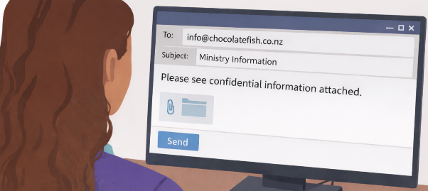
Answer: Sharing agency information with any person, organisation, or political party is a misuse of official information and sharing it with a political party undermines political neutrality.

Please Note
The answers above are specific to Ray's role as a Senior Advisor who has no contact with either Ministers or community members. Whether these actions are appropriate or not would vary based on:
- The seniority of the public servant's role.
- The nature of the public servant's role.
- The scope and scale of the political activity.

For example, it would likely be inappropriate for a senior public servant who is in the public eye or one who has a professional relationship with Ministers to be campaigning for a political party on personal time or appearing in political promotional material in a personal capacity.

Summary and Additional Resources


Now that you have worked through this learning, you should have a better understanding of the role and responsibilities of public servants in an election year.

Wrap up
This learning covered the key takeaways from the Election Guidance, but it is a good idea to read through the full guidance for a better understanding of what behaviour is appropriate for public servants during an election year.
He Ārahitanga Pōtitanga Whānui | General Election Guidance (Public Service Commission)

Reflection
At the beginning of this module, we asked you to reflect on how confident you were with understanding the requirements of public servants during an election year.
How are you feeling now? (1 = not confident at all, 10 = very confident).
If you're feeling more confident with what's required, then that's great! If you still have some questions or aren't sure about something in particular, then please ask questions.
It's useful to check out the additional resources below to help build your knowledge.

Additional resources
These resources will help build your knowledge further as a public servant around election time.
- Te Tauākī Whanonga mō te Rāngai Tūmatanui | Code of Conduct for the Public Sector (Public Service Commission)
- Cabinet Manual and Cabinet Office Circulars (Department of the Prime Minister and Cabinet)
- Election Period scenarios (Public Service Commission)
- Code of Conduct for the Public Sector learning resources (Leadership Development Centre)
- Political Neutrality learning resources (Leadership Development Centre)

Key Takeaways
- Public servants have the same rights to freedom of speech and political activity as other New Zealanders.
- The appropriateness of certain political activity in your private life is dependent on the seniority and nature of your role, and the scope and scale of political activity.
- Remember, keep your job out of your politics and your politics out of your job!

Certificate of Completion
Please see a link below to download a certificate should your agency require you to show proof of completion.
ldc.govt.nz/assets/Hub/Integrity/IntegrityEssentials/Getting-Election-Ready-Certificate.pdf

On the certificate it says:
Integrity Essentials
CERTIFICATE OF COMPLETION
Getting Election Ready
This learning has covered:
- The election period and its implications for the public service.
- Expectations of public servants during the election period.
- How public servants can safely participate in political activity in their personal lives.

