Navigating the Code


Every day, public servants make decisions that shape services and support communities. To do that work well, and to maintain trust and confidence in the public sector, we’re expected to act with integrity. To support this, the Public Service Commissioner has issued Te Tauākī Whanonga mō te Rāngai Tūmatanui | the Code of Conduct for the Public Sector (the Code).

  - Let's see what you already know
Discover some facts about Te Tauākī Whanonga mō te Rāngai Tūmatanui | The Code of Conduct for the Public Sector (the Code).
- The Code should be applied with judgement, not just as a checklist.
- Your behaviour outside work could result in a breach of the Code.
- If your organisation has its own code of conduct, it will be consistent with the Code.
- The Code applies to Public Sector organisations and all public servants working there.
One thing some public servants don’t realise about the Code is that it applies to every one of us.


Introduction
Kia ora, I’m Atama. Whether you’re new to the Public Sector or have been here for years, the Code helps shape the decisions we make every day. In this module, we’ll walk through what the Code expects of all of us, and how it guides the decisions we make, big and small. By the end, you’ll feel more confident recognising these expectations in real situations — and you'll know how they help us uphold the trust and confidence in public servants.

Reflection
Before we get started, take a moment to reflect on your current understanding of the Code.

On a scale of 1–10, how confident do you feel in your knowledge of what the Code expects of you in your role? (1 = not confident at all, 10 = very confident).

Remember your score, I will ask you again later in the module

Quote from Sir Brian Roche, Public Service Commissioner
“Integrity is not a one-off task – it requires daily commitment - it is an ongoing obligation for us as public servants. It is important that we are all on the same page when it comes to what integrity means in a contemporary and evolving Public Sector”.

The Code sets standards of integrity and conduct across the Public Sector.
It provides a shared foundation and commitment to integrity. It also sets clear expectations for the Public Sector. The Code reinforces our responsibility to serve the government of the day while maintaining public trust and confidence. This is a distinct feature of working in the Public Sector compared to anywhere else.
As a public servant, you must ensure you read, understand, and abide by the Code, and adhere to any extra behavioural expectations set by your organisation.
External link to: Te Tauākī Whanonga mō te Rāngai Tūmatanui The Code of Conduct for the Public Sector (Public Service Commission)

- The Code applies to all public servants, wherever you work in the Public Sector.
- It helps us act with integrity, unified by a spirit of service.
- It promotes fairness, impartiality, and accountability in everything we do.

Why it matters to you
Every decision you make as a public servant can shape trust in
government and impact the lives of New Zealanders.

Public servants hold a privileged position in serving our communities
and our country. The Code reinforces that our work for the public is
unique, meaningful and based on trust.

The Code isn’t just a set of standards — it’s a guide to help you navigate
complex situations with confidence, maintain fairness, and uphold integrity

.

By understanding and applying the Code:
- You contribute to something bigger — a Public Sector that is respected for professionalism and integrity.

- You safeguard your integrity — so your actions can withstand scrutiny, and you feel proud of the choices you make.

- You build trust and credibility — with colleagues, communities, and Ministers, which strengthens your influence and effectiveness.

- You reduce risk and uncertainty — knowing how to respond when faced with dilemmas like conflicts of interest, political neutrality or sensitive decisions.

Your organisation may also have its own code of conduct with different values or more standards. This is okay, organisational codes will be consistent with the standards in the Code of Conduct for the Public Sector.


How the values, principles and standards work together
The Public Service values and principles form the framework for the standards in the Code. There are 21 standards that are grouped around the values and principles. The standards are what we must do. They show the specific behaviours required to uphold the values and principles.

Think of standards as:
- The non‑negotiables.
- The things we must always do or avoid.
- The visible actions that show our values and principles in practice.

The values and principles point you in the right direction; the standards are the ‘road code’.
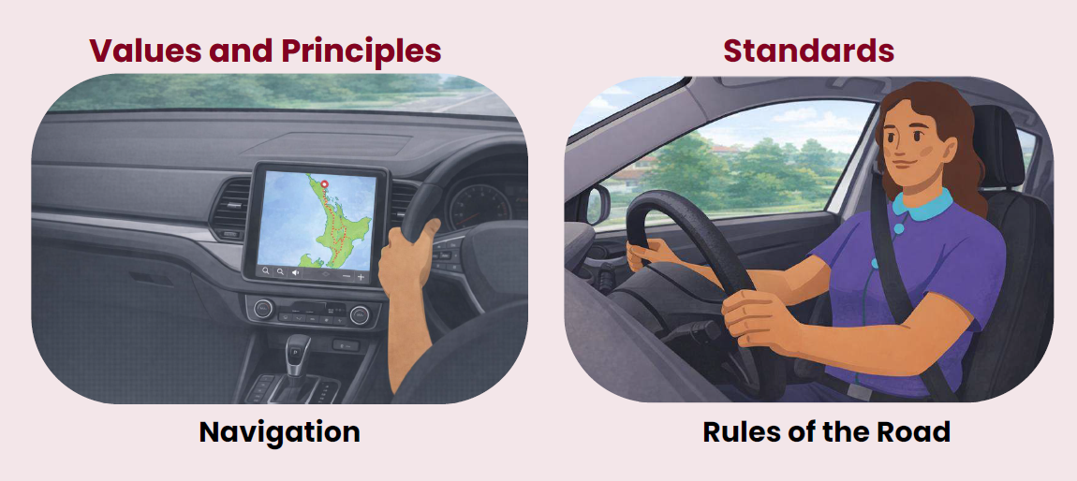

Values
Our values guide how we behave in every interaction.
- Trustworthy: To act with integrity and be open and transparent
- Respectful: To treat all people with dignity and compassion and act with humility
- Impartial: To treat all people fairly, without personal favour or bias
- Accountable: To take responsibility and answer for our work, actions, and decisions
- Responsive: To understand and meet people’s needs and aspirations

Standards
Trustworthy
- We are honest and professional.
- We act lawfully and use public power fairly and
- reasonably.
- We avoid work and non-work activities that may
- compromise our ability to do our job
Respectful
- We recognise and uphold the dignity of every person.
- We contribute to a positive and safe workplace culture.
- We act with care and respect, and do not behave in
- ways that are inappropriate or could harm others
Impartial
- We act objectively and do not allow our personal beliefs, interests, activities, or relationships to impact our work.
- We disclose our relevant interests and manage all conflicts of interest appropriately.
- We never misuse our position for personal gain or to benefit or disadvantage others.
- We decline gifts or benefits that place us under any actual or perceived obligation or influence.
Accountable
- We are open to scrutiny and can account for what we do.
- We treat our organisation’s information and resources with care and use them only for proper purposes.
- We aim to improve the performance and efficiency of our organisation.
Responsive
- We take the time to listen to and understand people’s circumstances and needs.
- We aim to collaborate and engage meaningfully with New Zealanders to design policies and deliver services that meet their needs and aspirations.

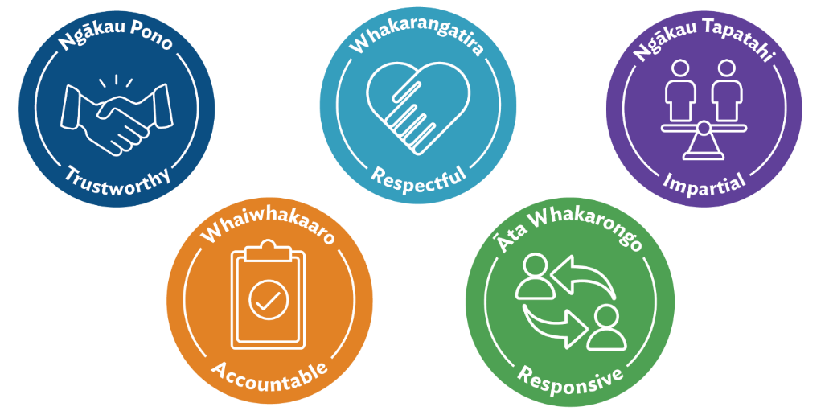

Principles
Our principles are foundational pillars that guide how the Public Sector works to achieve its purpose.
- Political Neutrality: To act in a politically neutral manner
- Free and Frank Advice: When giving advice to Ministers, to do so in a free and frank manner
- Merit-based Appointments: To make merit-based appointments (unless an exception applies under the Act)
- Open Government: To foster a culture of open government
- Stewardship: To proactively promote stewardship of the Public Sector

Standards
Political Neutrality
- We act in a politically neutral manner, which enables us to effectively serve current and future governments.
- We respect the authority of the government of the day.
Free and Frank Advice
- We support our organisation to provide Ministers with timely, robust, and unbiased advice.
Merit-based Appointments
- We are fair and robust in our recruitment and selection processes and must give preference to the person who is best suited to the position.
Open Government
- We aim to make government information, decisions, and services transparent, accessible and available.
Stewardship
- We manage and care for the Public Sector, so that it may continue to meet the needs of New Zealanders now and into the future.
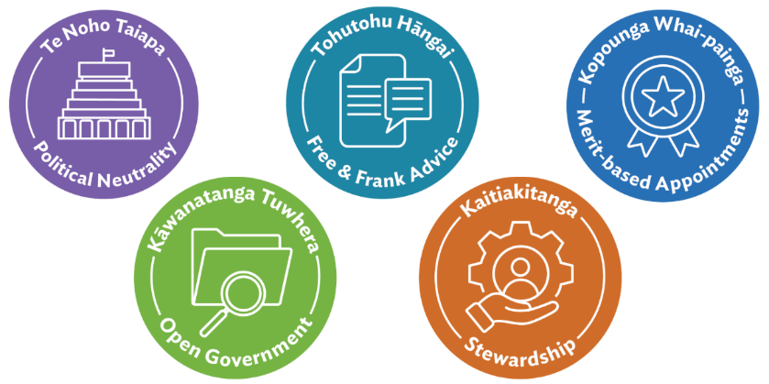

Sophie's Story

Meet Sophie
Sophie's a public servant who takes pride in doing the right thing.
Today, she notices something about a recent appointment that doesn’t feel quite right.
Follow her as she reflects, talks it through, and considers what to do next.

Scene One- The Announcement:
"We're pleased to announce Mark has been appointed Manager - Service Delivery"
Sophie pauses.
The role wasn't widely advertised. There was a short expression of interest process. Mark and the hiring manager are known to be close. She feels uneasy -but isn't sure why.

Scene Two - Is It Just Perception:
Sophie reflects:
- Was the process open and transparent?
- Were other capable people given a fair opportunity?
- Was merit clearly demonstrated?
Nothing looks overtly wrong. But the process felt narrow. And the outcome feels predictable.

Scene Three - A Conversation:
Sophie raises it quietly with a colleague, Liam.
"I might be overthinking it, but it doesn't feel like the strongest field was tested."
Liam nods and says:
"Remember - merit-based appointments are a principle in The Code of Conduct for the Public Sector."

Scene Four - Why Merit Matters:
Liam continues:
"Appointments must be based on merit -selecting the person best suited to the role through a fair and transparent process."
"It's not just about capability. It's about public confidence."
"If the perception isn't fair, that affects trust too"

Scene Five - What Could Sophie Do:
Liam suggests Sophie could:
- Seek clarity about how merit was considered in the process.
- Ask how conflicts of interests were managed.
- Speak to her manager, integrity champion, or human resources team, or raise anonymously through internal channels.

Scene Six:
Asking questions and seeking further clarity isn't about accusation. It's about protecting the integrity of the process - and public trust and confidence.

Making merit‑based appointments aren’t just a good idea - they’re a standard in the Code.
The Code tells us that when we make appointments, we must give preference to the person who is best suited to the job based on clearly defined criteria like skills and experience needed for the role, through a fair, open and contestable process.

In Sophie’s situation, her uneasiness didn’t come from one obvious rule being broken. Instead, it came from her sense that something felt unfair or narrow about the process.
Sophie had a chat to her manager who, without disclosing candidate information, talked her through the appointment process they had used. Sophie felt reassured because she could see that her agency had done the right thing.
That feeling Sophie had matters. Public servants are expected to uphold the Code not only in letter but in spirit — including being able to ask for clarity, fairness and transparency when they see a situation that doesn’t feel right.
Asking questions, seeking clarity, or raising concerns through the right channels helps uphold the integrity required of all public servants. It also strengthens trust in how we serve New Zealanders.

Let's work through this scenario

The On‑Site Check
Miriam works in a role that requires direct interaction with members of the public. This includes doing field‑based checks and verification visits.
She has a scheduled on‑site check with a community member, Sam, who interacts with the agency for a permit.
When Miriam arrives, Sam appears flustered.
Sam’s Request

Sam: "Can we just get this wrapped up today? The standard process takes too long. If you could fast‑track some parts, it would make a huge difference.”
“We’ve dealt with each other before. You know I’m doing the right thing. Surely you can just sign off based on what you see?”

How should Miriam respond to Sam?
- Acknowledge Sam’s stress, explain why process matters, and commit to doing what she can within her authority today.
- Agree to skip parts of the official process to help Sam - she knows he will do the right thing because she's dealt with him previously.
- Decline and insists on the full process without explanation

Acknowledge Sam’s stress, explain why process matters, and commit to doing what she can within her authority today.
Correct! This response:
- Shows respect by acknowledging Sam’s frustration
- Maintains fairness and consistency
- Keeps the process impartial and transparent

Agree to skip parts of the official process to help Sam - she knows he will do the right thing because she's dealt with him previously.
Not quite! This response:
- Undermines Accountability
- Erodes Trust
- Misuses public power
- Disregards impartiality
Decline and insists on the full process without explanation
There is a better way Miriam could have responded. This response:
- Could be delivered with greater care and respect
- Lacks responsiveness by not providing an explanation
- Sacrifices trust and rapport

Miriam: “I hear you — it can be frustrating. My role is to make sure the process is fair and consistent for everyone. We’ll work through what we can today, and I’ll be clear about next steps.”
Later, Sam shares sensitive information that is relevant to the permit process and says: “Please don’t put that part in your notes — that’s just between us.”
How should Miriam respond to Sam?
- Let Sam know you have to record the information, but clarify what information is needed in the future.
- Agree not to record the information
- Say everything must be recorded, with no explanation.
Let Sam know you have to record the information, but clarify what information is needed in the future.
Correct! This approach:
- Preserves trust in our processes
- Treats information appropriately
- Is respectful by remaining professional and providing reasons for steps being taken.
- Supports transparency and fairness
Agree not to record the information
Not quite! This response:
- Doesn't uphold Accountability – we should record all required information
- Isn’t trustworthy – we shouldn’t ignore relevant information for decision-making and it can also be unlawful, as laws and/or regulations usually prescribe what information is required.
- Lacks impartiality – not following the proper process by ignoring relevant information could be perceived as a misuse of position for the benefit of Sam.
Note: If Miriam is unsure, she could park that knowledge, check with someone else, then come back to recording the information before completing the permit process.
Say everything must be recorded, with no explanation.
Not quite! This response:
- Can damage trust and reflect poorly on professionalism
- Doesn’t demonstrate respect and responsiveness because Miriam doesn’t address the concerns raised by Sam
- Is only partially correct – not everything Sam says must be recorded, only relevant information to decide the permit should be. Conversational small talk doesn’t need to be recorded.

Sam appreciates the transparency and continues the discussion comfortably.
As Miriam is leaving, Sam says:
“My cousin runs an excellent workshop. If you say I sent you, he’ll give you a good deal.”

How should Miriam respond to Sam?
- Thank Sam for his generosity and explain she can’t accept benefits linked to her work and close out the conversation warmly.
- Accept the offer – it’s a great way to build a strong relationship with Sam
- Decline abruptly to avoid risk.
Thank Sam for his generosity and explain she can’t accept benefits linked to her work and close out the conversation warmly.
Correct! This approach:
- Respects Sam
- Meets Code requirements
- Avoids using our position for personal gain
- Closes the interaction professionally
Reminder: usually any offers for gifts and benefits should be advised to your organisation.
Accept the offer – it’s a great way to build a strong relationship with Sam
Not quite! This response:
- Doesn't uphold Impartiality
- Creates perceived preferential treatment, especially if Sam’s permit is approved
- Undermines professional integrity
- Is an improper use of Miriam's role for personal gain.
Decline abruptly to avoid risk.
Note quite! This response:
- Is technically correct and meets Code requirements around gifts and benefits.
- Could demonstrate greater respect and professionalism, by explaining why it is inappropriate while politely thanking Sam for the gesture.
During her site visit with Sam, Miriam upheld the Code's standards and demonstrated behaviours strongly aligned with the Values.

Values displayed
- Trustworthy: Consistently followed lawful, fair and reasonable processes throughout the visit.
- Respectful: Maintained professionalism and upheld the dignity of others, even when under pressure.
- Impartial: Ensured decisions were free from personal interest or bias.
- Accountable: She used information, tools, and delegated authority appropriately and transparently.
- Responsive: Actively listened, explained her reasoning clearly, and responded constructively to questions.
If Miriam had agreed to fast-track the permit, leave out relevant information, or accept a personal benefit, she would not just be “bending the rules.” She could be breaching the Code of Conduct for the Public Sector.

Why this matters
Miriam’s choices weren’t just about one permit. They were about protecting:
- the integrity of the process
- the fairness of decisions
- the reputation of her organisation
- the trust New Zealanders place in the public sector.

Summary and Additional Resources

Now that you have worked through this module, you will have a better understanding of the Code and how it applies to you.

Reflection
At the beginning of this module, we asked you to reflect on your current understanding of the Code.
On a scale of 1–10, how confident do you feel now in your knowledge of what the Code expects of you in your role? (1 = not confident at all, 10 = very confident)

Additional Resources
There are a number of resources you can also consult to develop your knowledge on the Code and other integrity learning topics.
- Te Tauākī Whanonga mō te Rāngai Tūmatanui | The Code of Conduct for the Public Sector (Public Service Commission)
- Election Learning Module (Leadership Development Centre)
- Political Neutrality Learning (Leadership Development Centre)
- Free and Frank Learning (Leadership Development Centre)

Key Takeaways
- The Code sets the standards for integrity and behaviour for all public servants and Public Sector organisations.
- As a public servant, you must ensure you read, understand, and abide by the Code, and adhere to any additional behavioural expectations set by your organisation.
- Failure to comply with this Code may constitute misconduct or serious misconduct and could result in disciplinary action being taken.

Certificate of Completion
Please see a link below to download a certificate should your agency require you to show proof of completion.
ldc.govt.nz/assets/Hub/Integrity/IntegrityEssentials/Navigating-Code-Certificate.pdf

On the certificate it says:

Integrity Essentials
CERTIFICATE OF COMPLETION
Navigating the Code
This learning has covered:
- What is included in the Code and how it should be applied.
- Why the Code is essential for maintaining trust and confidence in the public sector.
- The expectations of public servants set out in the Code.

