Choosing How to Implement an AI System
When considering how to implement an AI system for a specific use case, you will likely face a familiar question:
- Should we use an existing system?
- Should we adapt something to suit our context?
- Should we build something new?
- Should we utilise AI or other technological advancements?
Each of these pathways comes with different expectations. Some are faster to deploy. Some require more investment and responsibility. Others sit in between.

What’s Inside an AI System?
Before we look at the implementation options in detail, it helps to understand what makes up an AI system. Broadly speaking, most AI systems are made up of three layers (underpinned by infrastructure and compute – which is not covered here for brevity). Customisation may happen at one, two, or all three layers.
Understanding which layers are affected can help you assess what work is involved, and how much control you will have under the hood when implementing your AI system.

Application layer
What it is: What people interact with. This might be a chatbot, dashboard, or form.
How it might be customised: Often customised, even in lower-effort implementations.
Customisation layer
What it is: This is where the underlying AI is adapted to your domain or context.
How it might be customised: May involve local data, fine-tuning, or prompt design (GenAI).
Model
What it is: The foundation. The system has been trained to perform a task (such as generate text or classify data).
How it might be customised: Usually unchanged (especially for generative AI) unless building from scratch.
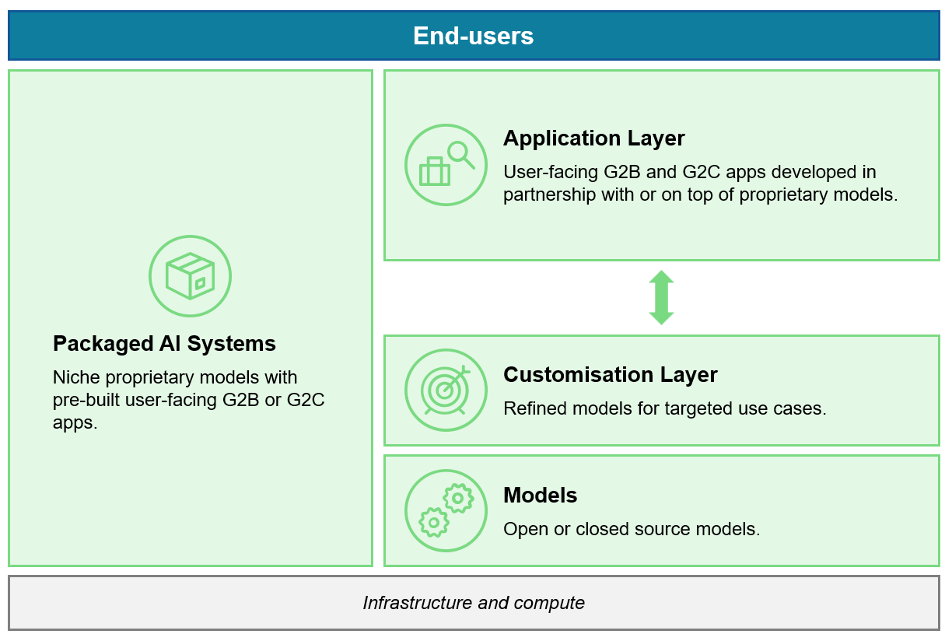

Overview of Implementation Approaches
The approach you choose for implementing an AI system will shape how the system behaves, how much influence your agency can have, and how much work is involved to get it running.
For simplicity, let’s consider three approaches we can take when implementing AI:
- The “Use” AI approach: Deploying an existing system with minimal change
- The “Adapt” AI approach: Customising an existing system to suit your needs
- The “Build” AI approach: Developing a new system from the ground up
Each approach affects different AI layers, as outlined below. No single approach is right for every use case. The best option depends on what the system needs to do, how it will be used, and how much customisation is required to make it effective and safe.
For those of you who are new to AI and tech, we know this may be quite overwhelming. In the three sections that follow, we have created questions and key points that you can ask yourself to help on your AI system implementation journey. If you need further advice, there are some key avenues that you could consider reaching out to the GCDO team.

What it involves
Aspect: Deploying an existing AI system as it is
Use: Tailoring an existing system to better fit your context
Build: Designing and building a new AI system
Affected layers
Aspect: Mostly application layer – Some setup may still be needed
Use: Application and customisation layers
Build: All three layers: model, customisation, and application
Speed to value
Aspect: Fastest
Use: Moderate, depending on scope of adaptation
Build: Slowest – requires time to develop, test, and deploy
Flexibility
Aspect: Limited
Use: Moderate
Build: High
Effort required
Aspect: Low
Use: Moderate
Build: High
Risk profile
Aspect: Typically lower, if security and data approaches are transparent. Managed predominantly via provider controls.
Use: Moderate. Depends on how adaptation is managed
Build: High. Full responsibility lies with the agency
Control over data and outputs
Aspect: Limited. Shaped by provider decisions
Use: Shared. Agencies influence data and outputs, but rely on base system
Build: Full control over inputs, outputs, and data handling

A Simple Framing
Thinking in terms of customisation and effort can help guide early decisions about which approach may fit best. While this framework does not capture every technical detail, it offers a digestible starting point to support structured, early thinking:
- How customised the system needs to be
- How much effort it will take to implement

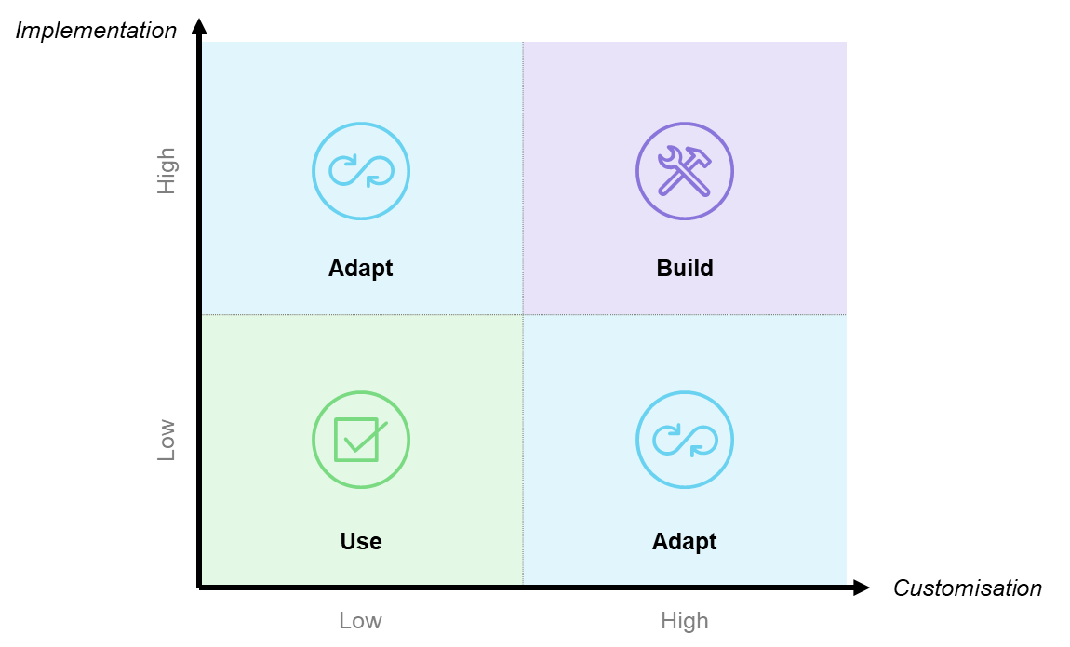

Use Approach: Deploying an Existing AI System
The Use approach involves selecting an existing AI system and deploying it with minimal modification. The system is typically pre-configured for a broad purpose and already operating in other settings.
In this approach, the agency activates the system, connects it to internal processes, and ensures appropriate oversight, but does not change how the underlying AI model works.
This can be a practical option when the task is well understood, the outputs are acceptable as-is, and the system can be implemented safely within public service expectations.

- Principle: Inclusive, sustainable development
What to Consider: System behaviour is shaped by the provider. Review whether fairness and accessibility has been addressed.
- Principle: Human-centred values
What to Consider: Agencies may have limited visibility over how data is stored or used. Review terms carefully.
- Principle: Transparency and explainability
What to Consider: Often limited to provider documentation. Check whether the system can be explained to users.
- Principle: Safety and security
What to Consider: Usually managed by the provider. Agencies must confirm these practices align with legal and agency requirements.
- Principle: Accountability
What to Consider: Agencies remain responsible for safe use in line with their risk appetite, even if most controls sit with the provider.

Key Questions
- Does this system meet the use case without major change?
- Have we reviewed the provider’s privacy, fairness, and security controls?
- What needs to be configured or integrated locally?
- How will we monitor how the system performs in our environment?
- Will users understand what the system is doing and how to use it safely?
Example: Automated Transcription and Document Summarisation
Implementation
Multiple public service agencies have adopted AI systems to transcribe meetings, hearings, or calls, and to summarise large volumes of documents.
Why Use Approach was appropriate
- These are routine tasks with common formats and predictable requirements
- The existing technology could be deployed quickly with minimal adaptation
- Human review was retained to ensure quality and contextual understanding
- The systems delivered immediate efficiency gains in administrative processes
What to note
Even in a Use scenario, internal configuration, access control, and staff training are essential. Agencies also remain responsible for ensuring that the system meets public service standards around transparency, privacy, and fairness.

Consider
Which of these examples are best suited to the Use approach?
Items to drag:
- Automated meeting transcription
- Standard document summarisation
Correct match: All items: Use
Feedback on correct drop: These are all examples where existing systems can be used with minimal change. The task is common, the output is acceptable, and the system can be monitored with standard controls.

Adapt Approach: Customising an Existing AI System
The Adapt approach involves taking an existing AI system and adjusting it to better reflect your needs. This could include changing how the system responds, integrating internal data, or aligning the outputs with specific policies, language, or content.
The system’s foundation remains the same, but the way it performs is shaped to suit your context. This approach offers more flexibility than using a system off the shelf, while avoiding the complexity of building from scratch.
Adapted systems can deliver better results for staff and the public, but they also require more expertise, governance, and monitoring.
Considerations
Principle What to Consider:
- Principle: Inclusive, sustainable development
What to Consider: Outputs can be improved, but new risks may also emerge. Performance, bias, and accessibility should be reviewed and refined as the system evolves.
- Principle: Human-centred values
What to Consider: Data use must be justified and ethical. Human oversight of key decisions is required, especially for high-risk models.
- Principle: Transparency and explainability
What to Consider: Customised responses may be easier to explain. Transparency is still influenced by the limits of the base system.
- Principle: Safety and security
What to Consider: Adaptation often involves integrating internal data. This must be handled securely and lawfully.
- Principle: Accountability
What to Consider: Greater control brings greater time investment into elements of accountability responsibility. Increased need for governance, including performance auditing.

Key Questions
- What level of adaptation is required: content, interface, or model outputs?
- Do we have the right skills and governance in place to manage those changes?
- Can we integrate internal data in a way that is ethical, secure, and effective?
- How will we monitor the system and address any unintended consequences over time?
- How will users understand what the system does, and what it cannot do?

Example: AI and Agency-Specific Chatbot for Customer Service
Implementation
Agencies internationally have experimented with using AI-powered chatbots to help people find information more easily. These systems have been adapted to reflect each agency’s specific services, policies, and language.
Why Adapt Approach was appropriate
- The underlying chatbot platform was already available
- Each agency needed the chatbot to reflect its own information and language
- Integration with websites and knowledge bases was required
- The systems had to respond to real questions from the public, with feedback used to refine responses over time
What to note
Even when the base system is the same, adaptation can make a significant difference in relevance and trust. Agencies must ensure that changes are tested, monitored, and documented. Custom content should reflect the diversity of users and uphold fairness, privacy, and accessibility standards.
Which of these examples reflect the Adapt approach?
- A chatbot that draws answers from agency policy
- A help tool trained on internal guidance
Correct: All items: Adapt
Feedback on correct drop: These are all cases where an existing AI system has been tailored to reflect the agency’s data, rules, or content. They require more effort than Use, and ongoing monitoring is essential.

Build Approach: Developing a New AI System
The Build approach involves designing and developing a new AI system from the ground up. This may include training a model, designing how it is customised for different uses, and building the interface or workflow that surrounds it.
This option is usually considered when no existing system can meet the specific needs of the use case. That might be due to technical constraints, legal obligations, or cultural expectations. It may also reflect the need for full control over data, behaviour, or outputs.
Build projects offer the highest degree of flexibility, but also introduce the greatest level of responsibility, complexity, and long-term commitment.
Considerations
- Principle: Inclusive, sustainable development
What to Consider: Agencies must identify and address bias and accessibility considerations early. Co-design and consultation may be important.
- Principle: Human-centred values
What to Consider: Supports full ownership of data flows and model behaviour. Alignment with Te Tiriti o Waitangi may be needed.
- Principle: Transparency and explainability
What to Consider: Completely controlled by agency. Can be built in, but requires deliberate planning, clear documentation, and skilled design.
- Principle: Safety and security
What to Consider: All systems must be designed with strong protections from the outset. Agencies are fully responsible.
- Principle: Accountability
What to Consider: Strong governance is essential. Plans should include updates, retraining, maintenance, and performance review.

Key Questions
- Is there a clear reason this cannot be solved through an existing system or adaptation?
- Are the right skills, resources, and governance in place to support full development?
- How will ethical, legal, and cultural considerations be reflected in the design?
- What are the plans for testing, oversight, and long-term maintenance?
- Will co-design with communities or experts be needed to ensure the system is fit for purpose?
Example: AI for Environmental and Wildlife Monitoring
Implementation
Government agencies and research institutes in New Zealand and around the world have developed AI systems to analyse unique environmental data, such as camera images for tracking wildlife.
Why Build Approach was appropriate
- The system needed to recognise native species that were not well represented in existing models
- Integration with specialised field equipment and environmental databases was required
- The project involved scientific expertise and collaboration with researchers
Off-the-shelf solutions could not meet the technical or ecological requirements
What to note
These systems deliver public value by supporting conservation and environmental management. They also require dedicated capability to manage data, models, and ongoing improvement. Collaboration, governance, and sustainability planning are key to success.
Which of these examples are good candidates for the Build approach?
- An AI system that recognises rare native species from camera images, not found in other accessible AI systems
- A rare tool to support indigenous language and dialect services
Correct match: All items → Build
These examples need full control, specialised design, or deep alignment with local data and values. They cannot be delivered through adaptation alone and often involve co-design and collaboration.

Conclusion: Making Informed, Defensible Choices
Introducing an AI system into public service is not just a technical decision; it is strategic, shaped by the level of customisation needed, the effort involved, and the responsibilities with each approach.
You have considered three main implementation approaches (Use, Adapt, and Build), what they involve, the risks they carry, and their alignment with public service values. However, it's crucial to consider the current agency ecosystem when discussing AI systems. While these systems often excel in pilot and sandbox environments, scaling them can be challenging due to security issues, enterprise risks, technological constraints, and commercial considerations inherent to the existing landscape.
No single option is always best, and a mix of approaches may be used. Each use case will have its own context, constraints, and opportunities. What matters is taking a clear, structured approach to weighing up the options, asking the right questions, and being ready to explain your reasoning.
As you continue your learning or prepare to evaluate a use case, keep in mind:
- Start with the problem. Understand what the system is meant to achieve.
- Assess the level of customisation required. This will guide effort, risk, and responsibility.
- Think about long-term impact. Consider what the system will require to stay safe, fair, and effective over time.
You do not need all the answers right away. What you need is a thoughtful, defensible starting point – one that supports public trust, upholds the values of the public service, and delivers value for Aotearoa.
This module has presented a simplified view to support early decision-making. It does not replace detailed technical advice or formal assessment. In practice, use cases may involve a mix of approaches, or shift over time as needs evolve.

