Te Tautuhi ō Rongo in Action

Te Tautuhi ō Rongo: the Framework
Te Tautuhi ō Rongo means to listen, consider, and analyse deliberatively before speaking, writing, and advising.
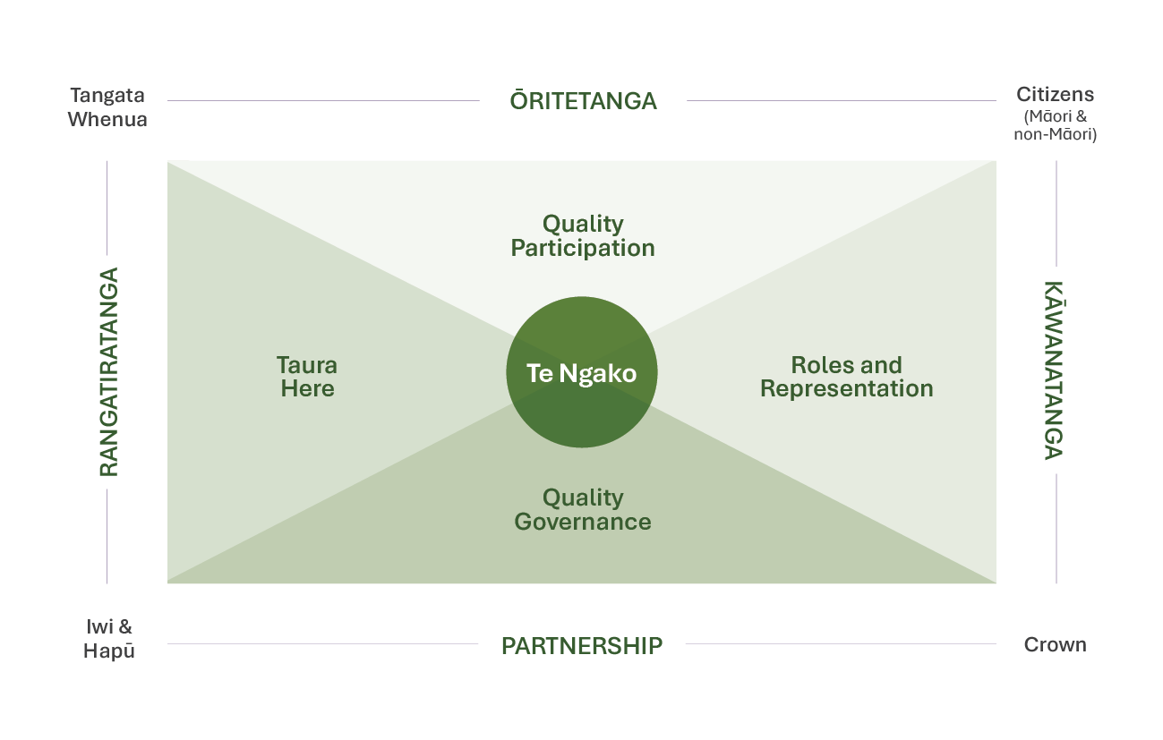

How to use Te Tautuhi ō Rongo within your work
Te Tautuhi ō Rongo helps public servants think carefully about who is affected by a policy or issue. It guides us to work in a way that considers both the collective rights, interests and responsibilities of Iwi and hapū, and individual rights of Māori as citizens of Aotearoa New Zealand. This helps us provide better quality advice and make better decisions that give effect to Te Tiriti | The Treaty.
So, the best time for me to utilise Te Tautuhi ō Rongo would be early in the process rather than at the end!

The 4 Step Process
- Locate Yourself
- Identify the Issue or Opportunity
- Locate the Representative Communities
- Explore Te Ngako (the desired outcome)
These steps help to provide structure and prompts you to consider and expand your thinking and exploration.

Step 1: Locate Yourself within the Framework
Where you sit
As a public servant, you are always located on the Kāwanatanga Axis – representing the government of the day.
Why understanding where you sit matters
- Recognising your position helps you understand the perspective you bring to policy or engagement.
- Under Section 14 of the Public Service Act 2020, you carry responsibility for supporting the Crown in its relationship with Iwi and Māori under Te Tiriti o Waitangi | The Treaty of Waitangi (Te Tiriti).
These prompting questions can help you to reflect on your role and representation as you use Te Tautuhi ō Rongo:
- Who am I in my work? How do I know?
- What is my role in this issue or opportunity?
- Who am I not in my work? How do I know?

Step 2: Identifying and locating the Issue or Opportunity
Before jumping into solutions, it's important to pause and ask questions. For example: "What is the issue or opportunity we’re working on, and who does it affect?"
Taking time to answer the example questions below helps you choose the right approach and connect with the right people:
- Who is responsible for addressing the issue or creating the opportunity?
- Who is affected or impacted?
- Is this a right, or issue, from the perspective of governance or citizenship?
- Does it impact whānau, hapū and/or Iwi as tangata whenua, Māori as citizens, or both?
There might also be other questions specific to the issue or opportunity you are analysing.
This step helps you locate the issue within Te Tautuhi ō Rongo, so your advice, engagement, and/or policy design is
better informed, more inclusive, and more likely to lead to meaningful outcomes.
Take a look at the example below. Which answers are correct? Hint: more than one may apply.
A new housing initiative will be trialled in Northland. The initiative is led by a government agency and is intended to serve the wider local population. Which groups rights, interested and responsibilities do you need to consider first?

- Hapū and Iwi in the region
- Māori as citizens
- Other local citizens
- All three groups

The correct answer is all three. You need to consider the rights, interests and responsibilities of all these groups first.
- Hapū and Iwi in the region – because as tangata whenua they hold collective rights, interests and responsibilities, and any policy in their rohe must engage them as Treaty partners.
- Māori as citizens and tangata whenua – because housing is a citizen right. Under Article III of the Treaty, the Crown promises that its obligations are to all Aotearoa New Zealand citizens, including Māori as tangata whenua, promoting equality of opportunity between all citizens. The rights and interests of Māori communities must be considered.
- Other local citizens – because Kāwanatanga requires the Crown to act for all citizens, Māori and non-Māori alike.

Step 3: Locate the Representative Communities
Representative communities on the framework include
- Tangata whenua
- Iwi and hapū
- Citizens (Māori and non-Māori)
- The Crown
Why it matters
Understanding which community each person or group represents helps you:
- Speak with the right people when engaging or consulting.
- Respect cultural obligations and responsibilities.
- Make informed decisions that reflect diverse needs, rights and interests.
- Avoid overlooking critical perspectives and voices
Prompting Questions:
- Is this an individual or collective issue?
- Does the individual have whakapapa Māori?
- Are they representing hapū or Iwi, and do they have the mandate to do so?
- What other communities or stakeholders need to be considered?

See the representative communities under each group.
Tangata whenua
- Ngā Whātua Ōrākei as people of Tāmaki Makaurau
- Connections to the Bay of Plenty region through whakapapa-based relationships
Iwi and hapū
- Post Element Governance Entity (PSGE) (e.g. Te Rūnanga o Toa Ranga ra)
- Māori Land Trust
Citizens (Māori and non- Māori)
- Ratepayers Association
- Homeowner
The Crown
- Public servant
- Te Taura Whiri i te Reo Māori | Māori Language Commission

Step 4: Explore Te Ngako, the desired outcome
Te Ngako means the essence or the heart of what you want to achieve. It’s the guiding vision that shapes all your mahi
Understanding Te Ngako helps you:

- Clarify the long-term purpose of your project.
- Align your work with whānau, hapū, Iwi, and Crown priorities.
- Make decisions that are consistent, meaningful, and culturally appropriate

Prompting Questions
- What outcome are we aiming for?
- Will this change or intervention affect whānau, hapū, Iwi, or Māori as citizens of Aotearoa New Zealand - and then if so, how?
- Will it enable rangatiratanga or strengthen partnership?
- Does it reflect the roles and representation of Māori as tangata whenua and as citizens of Aotearoa New Zealand?

You can think of Te Ngako as any of the following:
Long-term aspiration
- The big-picture goal you want to see achieved.
- Example: All tamariki in the community have safe, healthy housing by 2030.

Specific policy target
- A measurable outcome that supports broader aspirations.
- Example: Increase the number of affordable homes built in Northland by 15% this year.

Bespoke solution designed with whānau, hapū, Iwi
- A tailored solution created collaboratively.
- Example: Develop a housing plan co-designed with local hapū that incorporates customary land use practices.

Partnership with the Crown
- Working with government agencies to achieve shared goals.
- Example: Establish an initiative between Iwi and central government to deliver culturally appropriate housing solutions that respond to whānau needs.

Something to reflect on...
How would you describe Te Ngako (the desired outcome) in your own work?
Hint: When thinking about your own work, make sure you consider:
- The big-picture aspiration of their project.
- How it aligns with whānau, hapū, and Iwi aspirations, and the Crown’s priorities.
- Any measurable targets or targeted solutions they envision

End.

