What is Te Tautuhi ō Rongo and why is it important?
"Te Tautuhi ō Rongo means to listen, consider, and analyse deliberatively before speaking, writing, and advising."
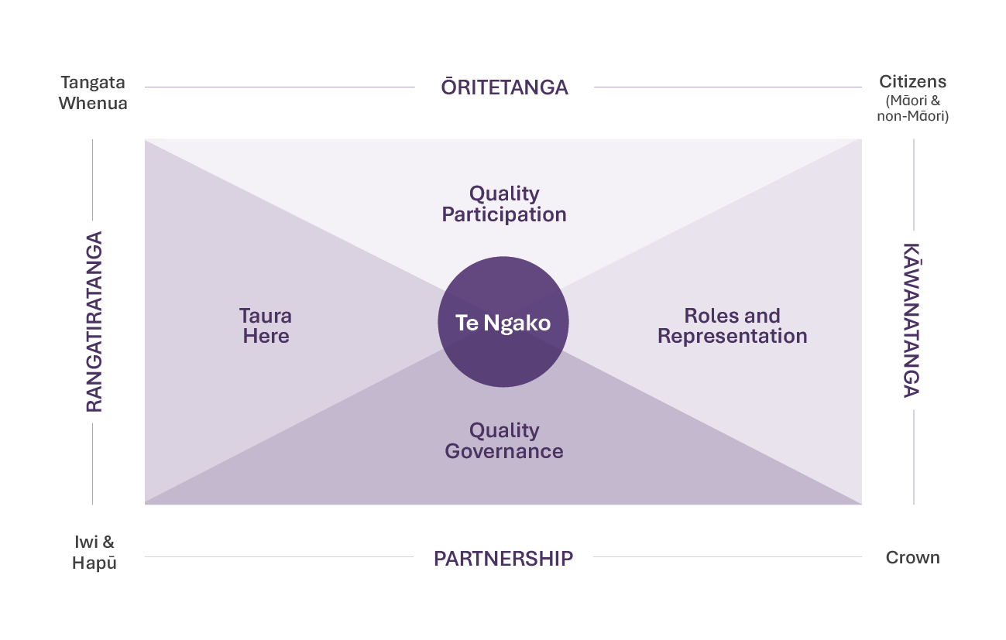

What is Te Tautuhi ō Rongo?

Key Features:
- Grounded in the articles and principles of Te Tiriti o Waitangi | The Treaty of Waitangi (Te Tiriti).
- Considers the rights, interests and responsibilities of both collectives (whānau, hapū, Iwi) and individuals (Māori as citizens of Aotearoa New Zealand).
- Provides a structured approach to exploring these rights, interests and responsibilities when examining an issue or opportunity, developing or implementing policy, improving regulation, or engaging with stakeholders.
Te Tautuhi ō Rongo is a Māori public policy framework that supports public servants deliver better policy and engagement outcomes, grounded in a positive reading of Te Tiriti.

It encourages thoughtful, inclusive, decision-making across all stages of policy development and engagement to assist the Crown in giving effect to Te Tiriti.
So, Te Tautuhi ō Rongo can help me to differentiate between the collective rights, interests and responsibilities of hapū and Iwi, as well as the individual rights, interests and responsibilities of Māori as citizens of Aotearoa New Zealand. This will be so helpful for my analysis.

Why It Matters for Public Servants
Te Tautuhi ō Rongo helps public servants:
- Distinguish between the collective rights, interests and responsibilities of hapū and Iwi, and those of individual Māori as citizens of Aotearoa New Zealand.
- Understand the distinct roles and responsibilities of Māori as members of hapū and Iwi, as tangata whenua and as citizens.
- Clarify who we mean by ‘Māori’ when working on public policy.
- Avoid policy failures caused by conflating collective and individual rights, interests and responsibilities.
- Improve the quality of advice and engagement by identifying who is impacted and how.


Te Tautuhi ō Rongo aims to address the problem of policies that don’t meet the real needs of the people they’re meant for.

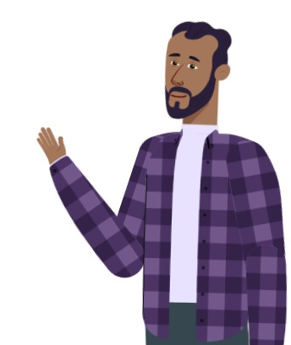

Yes, because when we understand who we are making policy for, we can best address their needs, interests, rights and responsibilities

Origins and Development
Te Tautuhi ō Rongo was first conceptualised by Hekia Parata in the 1990s. It has evolved through several key milestones since then.
1997: Introduced as a Treaty framework by Hekia Parata at a NZ Law Society seminar with Honourable Justice Baragwanath & Honourable Sir Joe Williams.
2020: Te Puni Kōkiri self-initiated a performance improvement framework review, which identified the need for a Māori public policy framework. Developed through Te Whare Wānanga o Awanuiārangi, this framework is known as Te Tautuhi ō Rongo.
2024: Cabinet noted that Te Tautuhi ō Rongo can serve as a consistent policy tool across the public service. The Minister for Māori Development set the expectation that Te Tautuhi ō Rongo be used across the public service to help draft policy related to Iwi and Māori.

Locating Public Servants within Te Tautuhi ō Rongo
As public servants, we are always located on the Kāwanatanga Axis. This is because in our public service roles we are representing our agencies and the government of the day. Our role includes:
- Providing free and frank advice.
- Assisting the Crown in giving effect to Te Tiriti.
- Ensuring policy reflects both citizenship and whakapapa-based rights, interests and responsibilities.

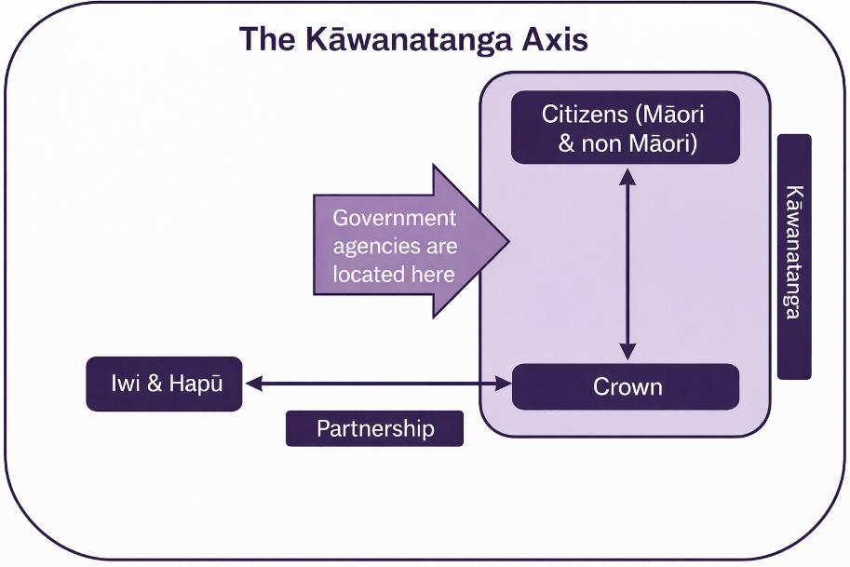

Something to reflect on...
Why is it important to distinguish between Māori as members of hapū and Iwi, as tangata whenua and as citizens?

End.

